Type of Meeting: Study session, during class

Date: 15 July 2020

Attendees:

**Team Delta:** Ivan, Michael, Melvin, Jarred, Lord

**Team Zeta:** Yonatan, Darrius, Veronica, Christian, Desmond, Thierno

**Team Eta:** Edvige, Robert, Beruk, Horace, Hana

Notetaker: Yonatan

------------------------------------------------------------------------------------------------------------------

Class notes:

Group study code: <https://repl.it/@ChristianMorra/ZetaEtaDelta#main.py>

Working as a group practicing Vocarrum Python Lab 3:

* Build-in functions: print(), count()
* Defining dictionaries
* Dictionary is a type oWhile f variable
* While loop with an argument and conditional to calculate the charge
* Dictionaries are comprised of an immutable key associated to its value. Keys must be immutable data types. (Ivan posted)
  + Dictionaries can be nested inside of each other.
  + To create an empty dictionary, use a pair of braces with nothing inside: {}
  + Keys are separated from their values by a colon: {"Key":"Value"}
  + Retrieve value in the dictionary by its key: myDict.get("key") or myD

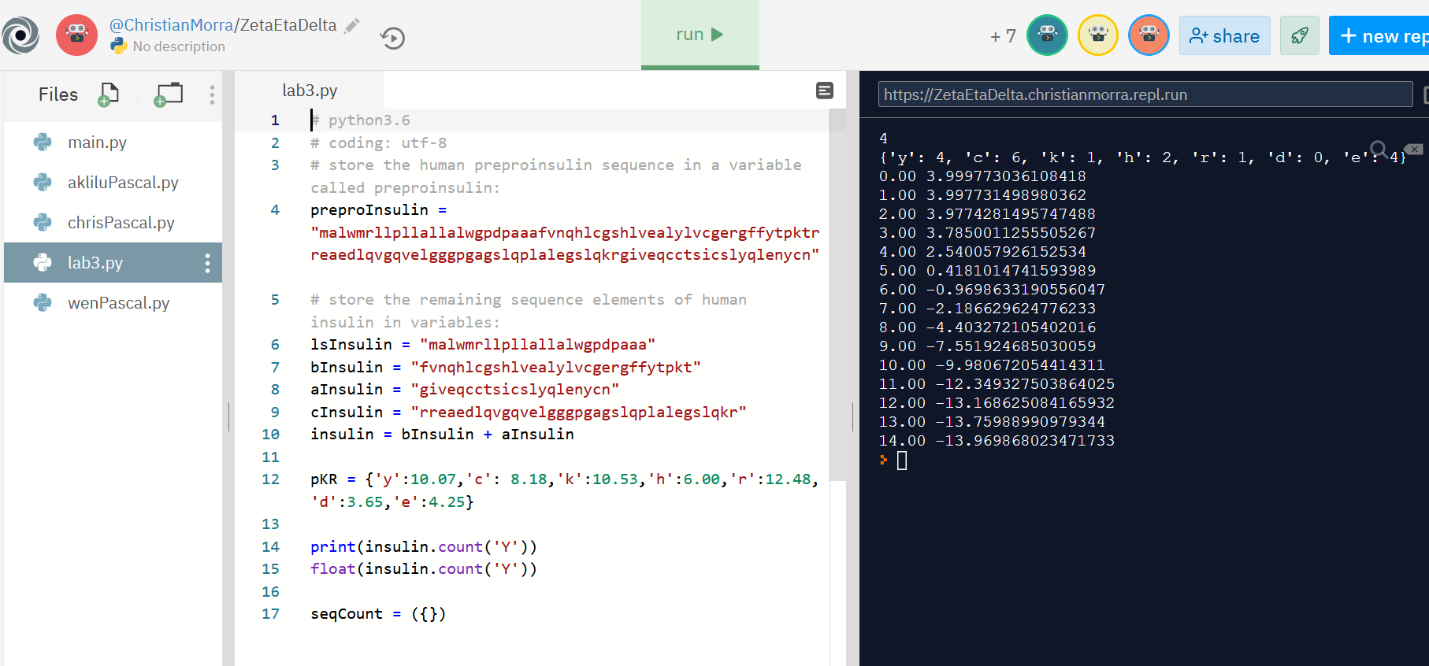

Now are now moving the files from Repl to a Github repo:

* Created a py file by c+p the contents of the file
* Created, add the new repo to Github
* Commit and then push the file to Github to the correct repo
  + <https://github.com/ibacai/mega_team_repo>

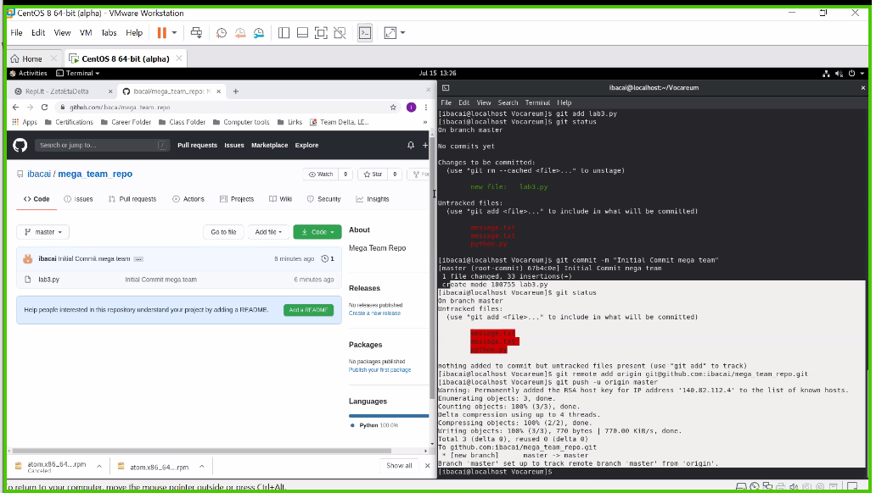

We are not going over Vocarrum Python Lab 4:

* Learning to navigate through Repl a little.
* Calling a function
* Parameter in a function grabs the variable it is calling
  + The terms **parameter** and argument can be used for the same thing: information that are passed into a function. ... A **parameter** is the variable listed inside the parentheses in the function definition. An argument is the value that is sent to the function when it is called.
  + Source: <https://www.w3schools.com/python/python_functions.asp>
* Built-in function return: asks what are we getting
  + A **return** statement is used to end the execution of the **function** call and “**returns**” the result (value of the expression following the **return** keyword) to the caller. The statements after the **return** statements are not executed. If the **return** statement is without any expression, then the special value None is **returned**. Source: <https://www.geeksforgeeks.org/python-return-statement/>
* Use three quotes and \ to use multiple lines
* Style limitation of 79 for a string for appearance and above wrap-arounds
* We have created a functions but have not “called anything out”

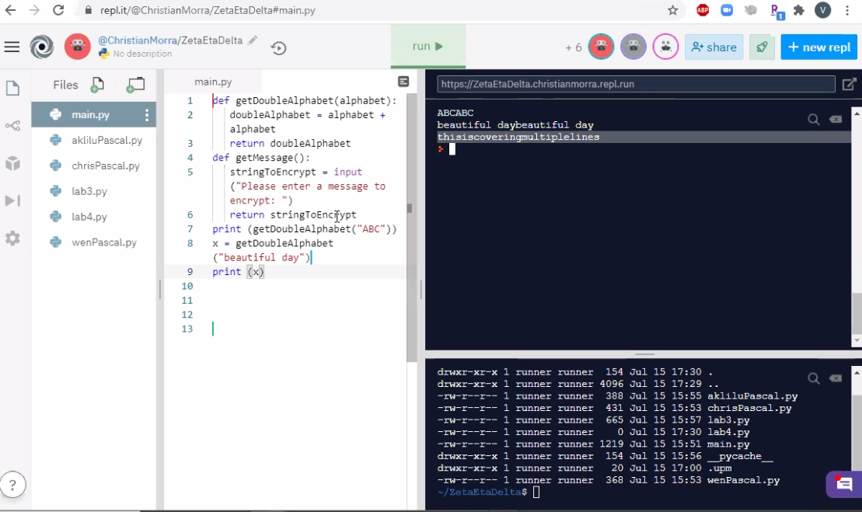

* Functions are normally long but for this lab it is small for understanding how a variable works
* Testing out a function: printMany(x):
  + x is the parameter
  + Range is the function
  + The for-loop will continue till it reaches the input
  + X is a mutable variable

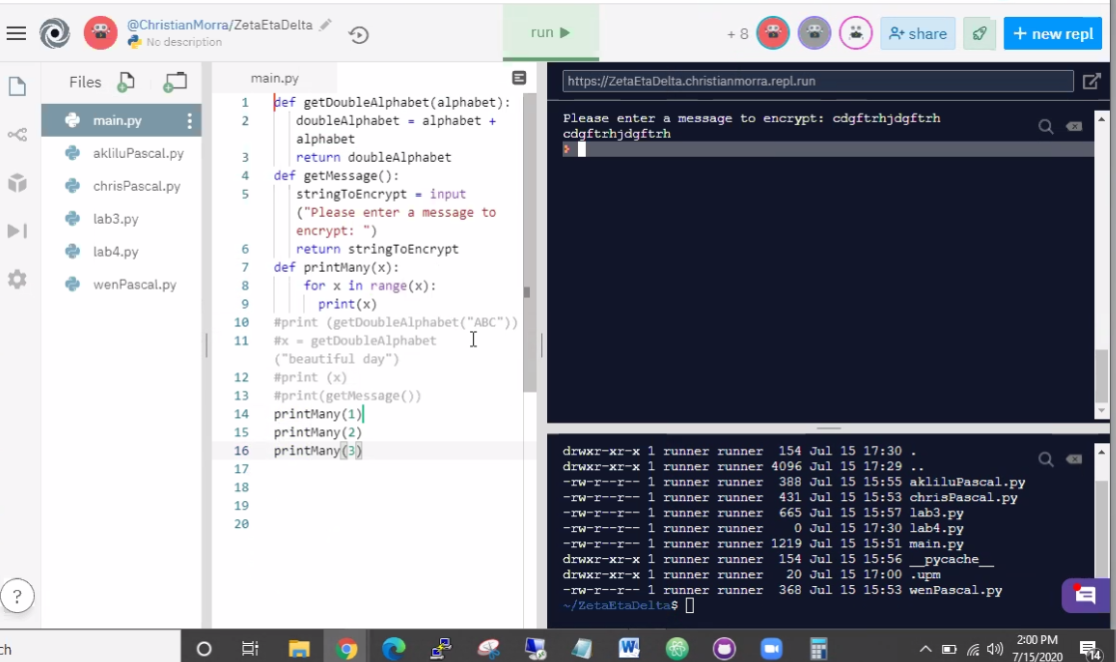

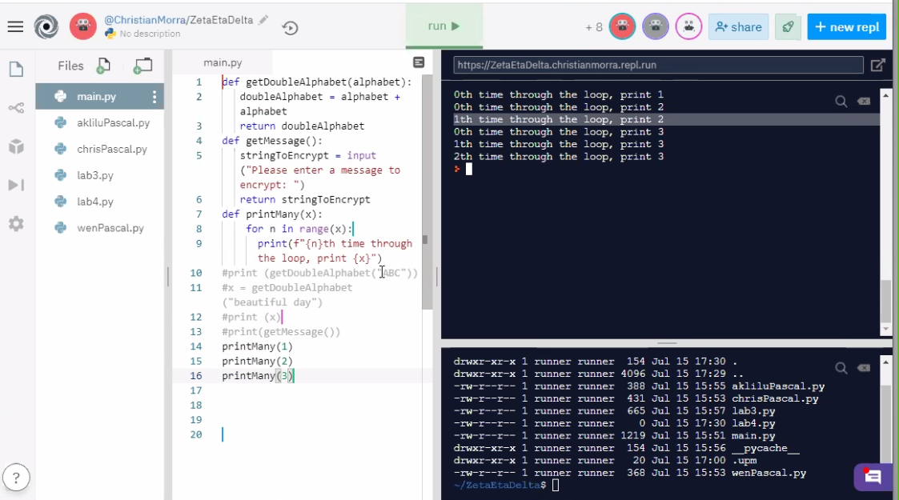

* **Example** of using a for-loop and a while-loop producing the same result:

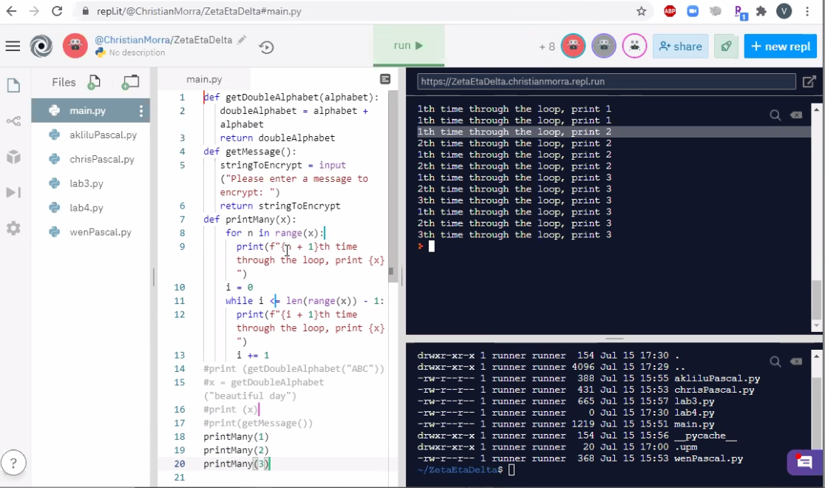

* Functions are important to make the code easier to read.
* Import function is used bring a package to your program
* Method “just runs a block of code”,“methods are like verbs” - Christian
  + Methods and objects: Methods in objects are functions that belong to the object.

Source: <https://www.w3schools.com/python/gloss_python_object_methods.asp>

* What is a Cesar Cipher: It shifts the letter in an amount spaces

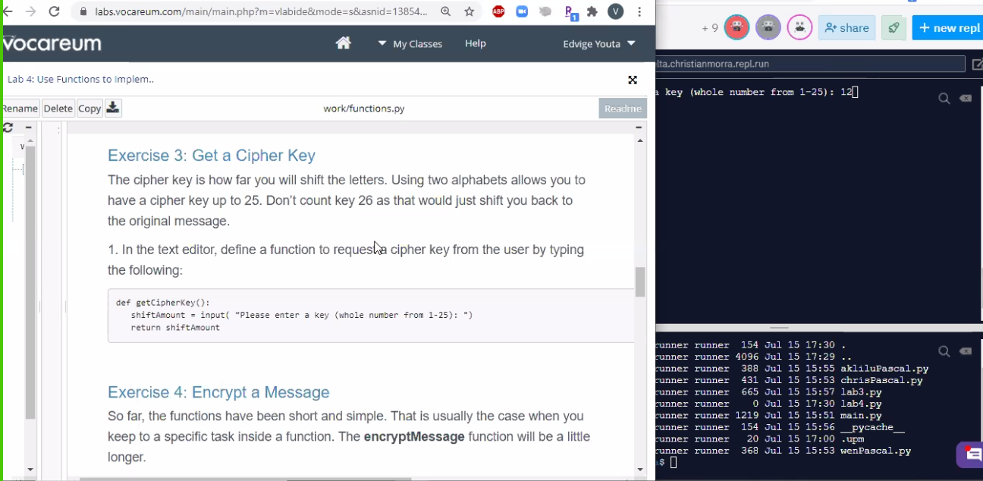

* Berul Ambatchew shared: <https://en.wikipedia.org/wiki/Caesar_cipher>

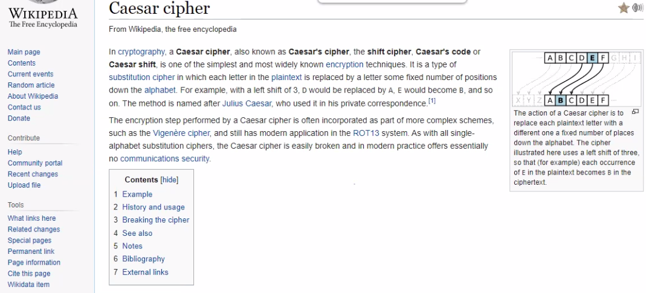

* We are now writing the algorithm for the Caesar Cipher
* Explanation of how to cipher:

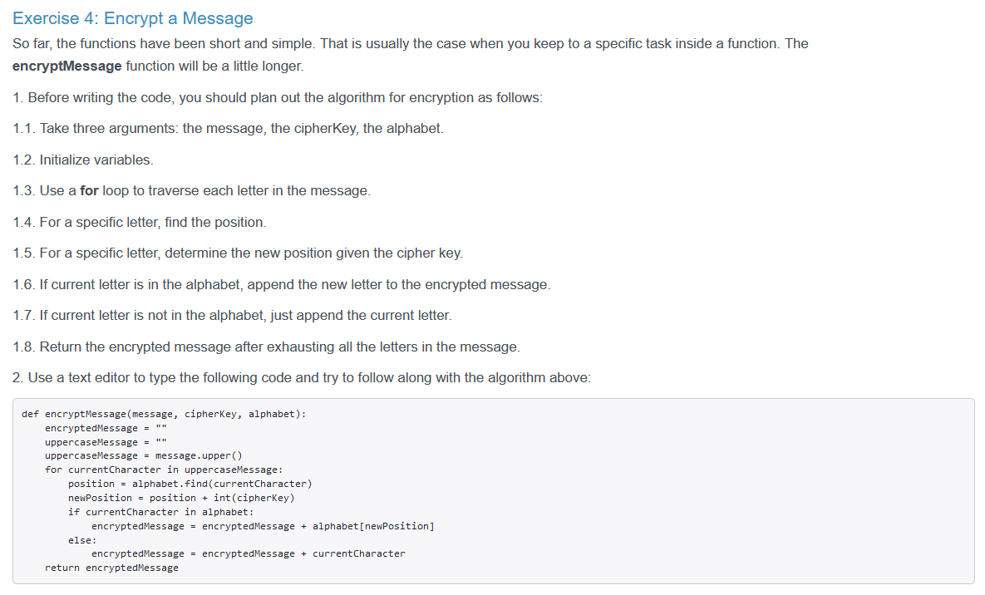

* Looking at each line of code to see if we have any mistakes

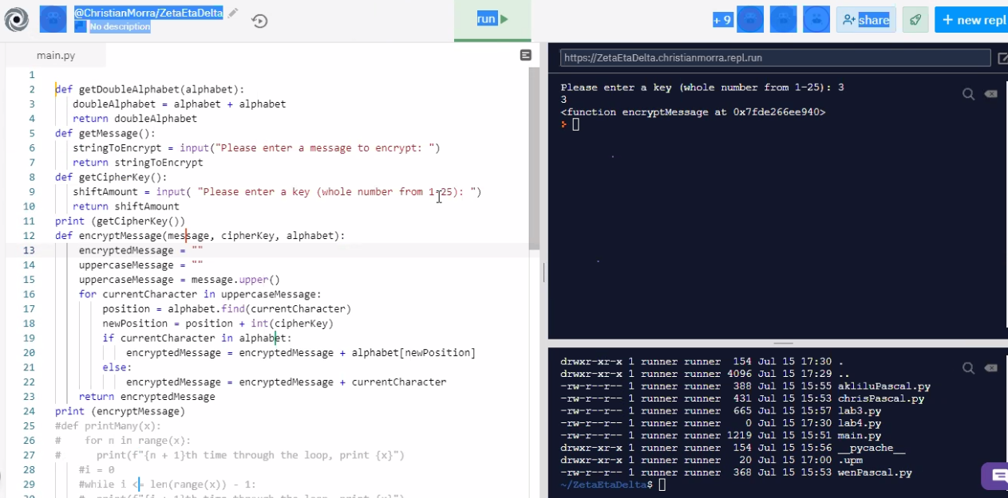

* Local variable example of running fish which equals 5:
  + Function has not argument
  + Fish variable is created within the local scope of the function, which means it can only be used in this function and not the global scope of the code
  + We are returning, or grabbing, the fish variable which was created within the function which means it is a local variable

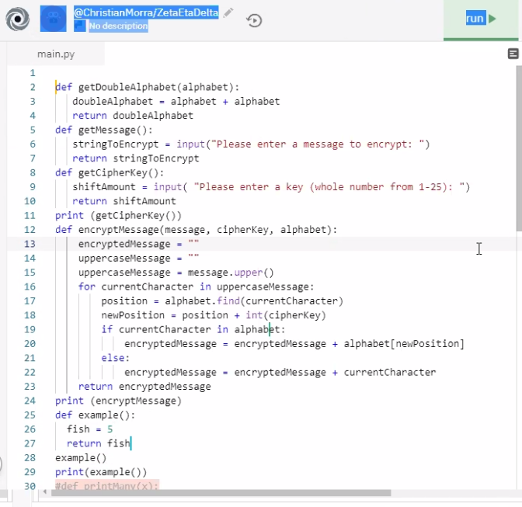

* Running the script to see what it looks like:
  + encryptedMessage and uppercaseMessage declares
  + Build-in functions list: <https://docs.python.org/3/library/functions.html>
  + for currentCharacter in uppercaseMessage
  + Position will find the location of the currentCharacter
  + newPosition will shift the letter over
  + If the user puts in an invaild letter, it will be untouched: if currentCharacter in alphabet conditional
  + Running the function for this test produces the following:

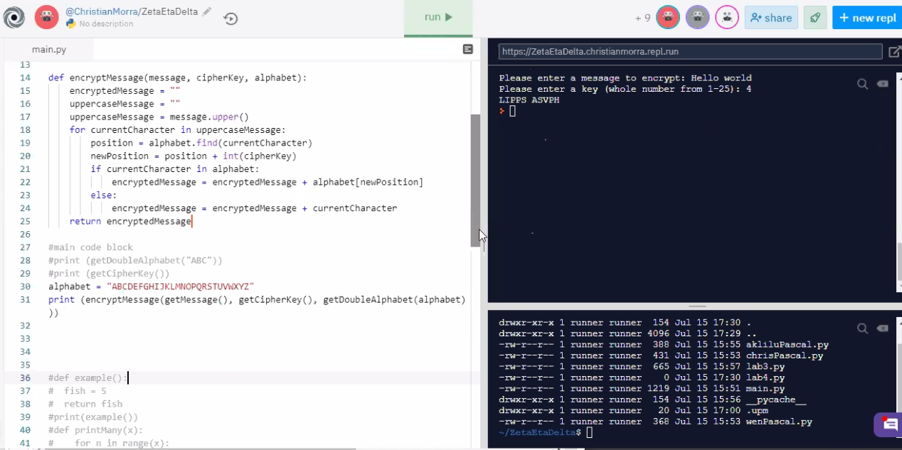

* VIsual of how a for-loop works with: hello world:
  + Location of the index in the array is important for how it prints.
    - The ‘h’ is x [0], ‘e’ is x[1], etc.

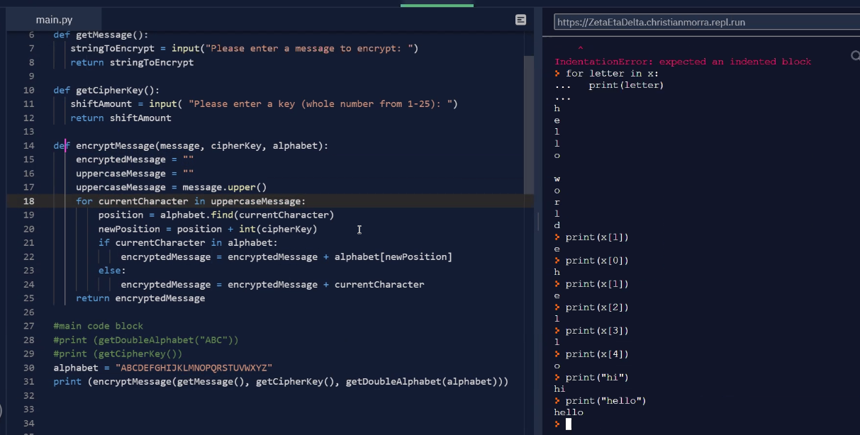

* Shifting the index in the amount of the cipher key, with an example:

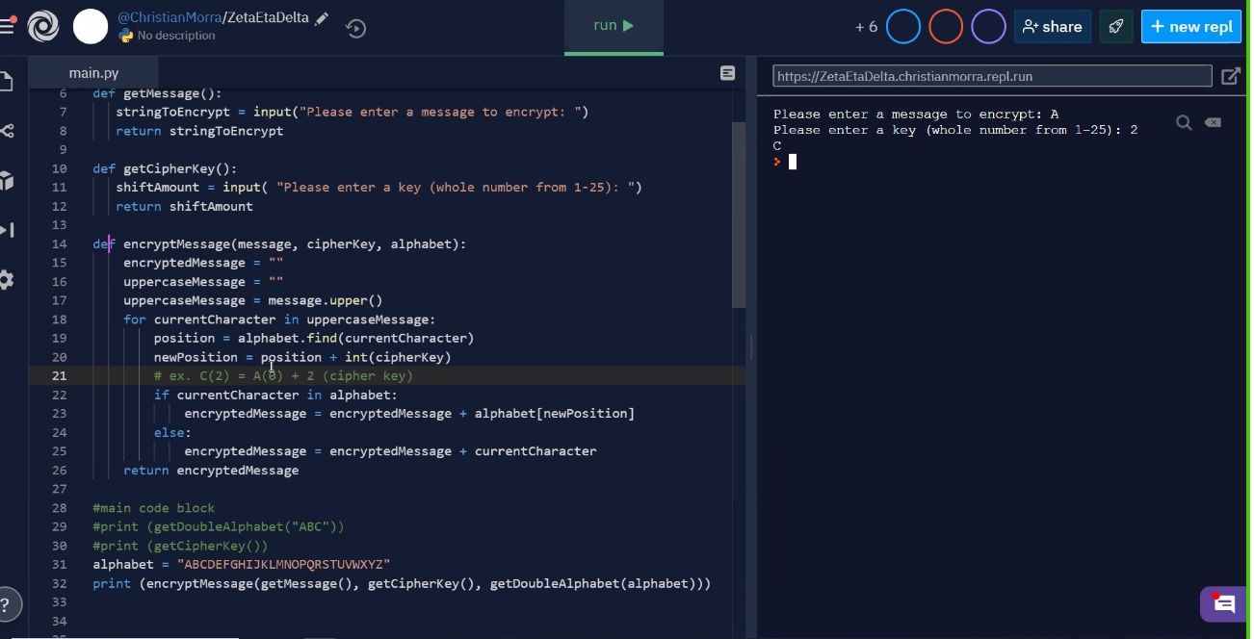

* Reason we have a double alphabet is for when the shift occurs there will still be a letter to produce the outcome:
  + We are trying to access an index

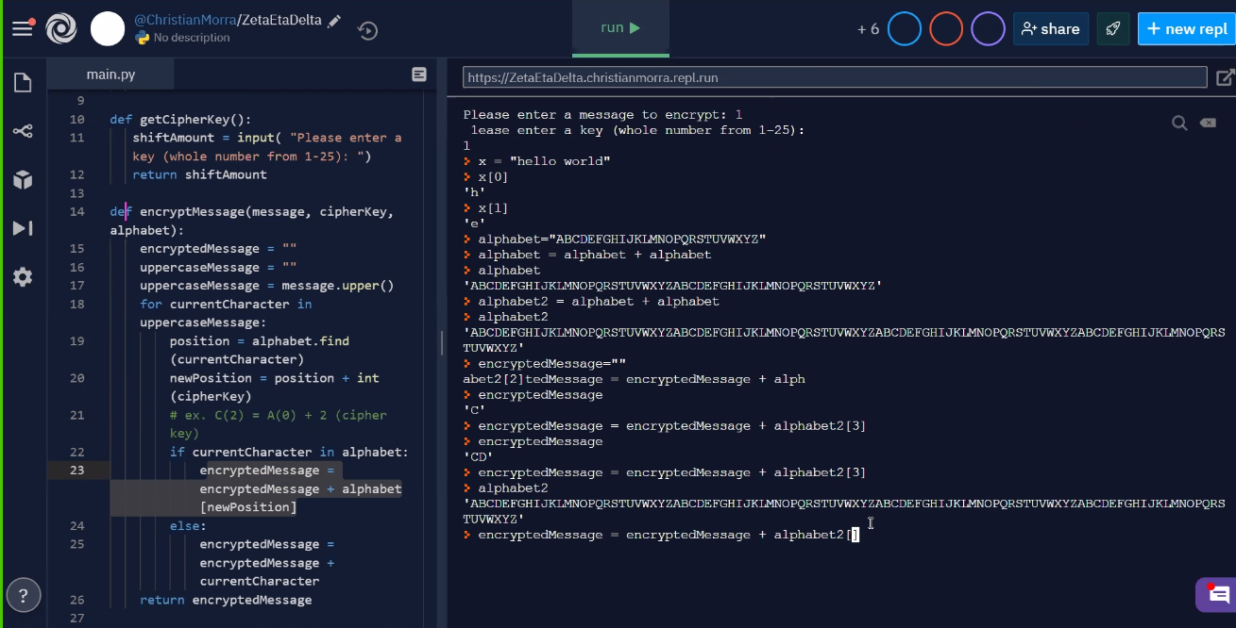

* We are not moving files over to Github.
  + https://github.com/ibacai/mega_team_repo

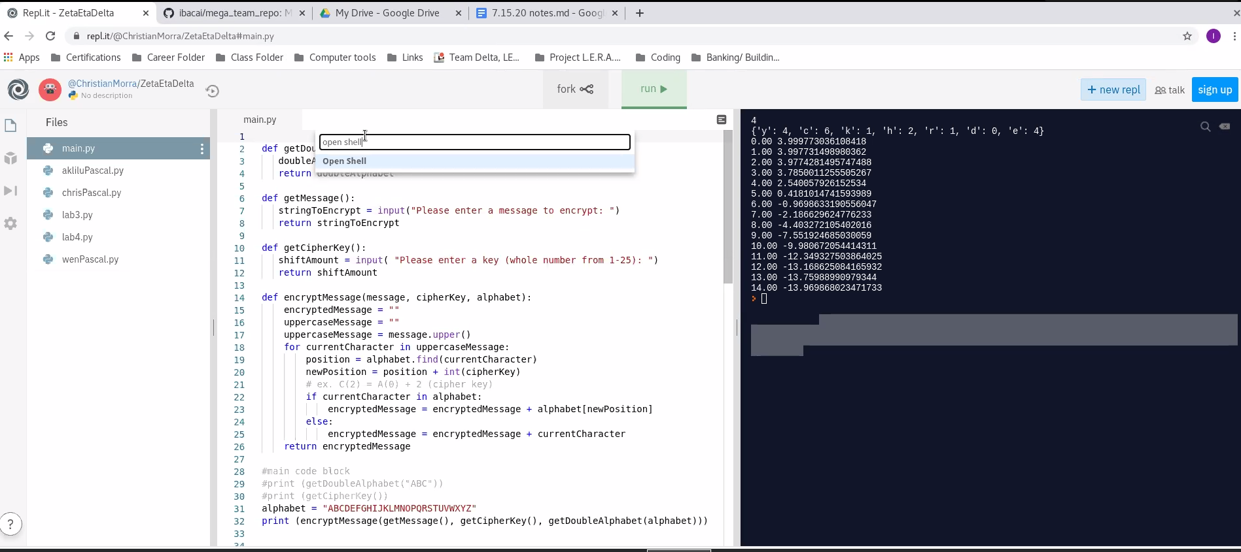

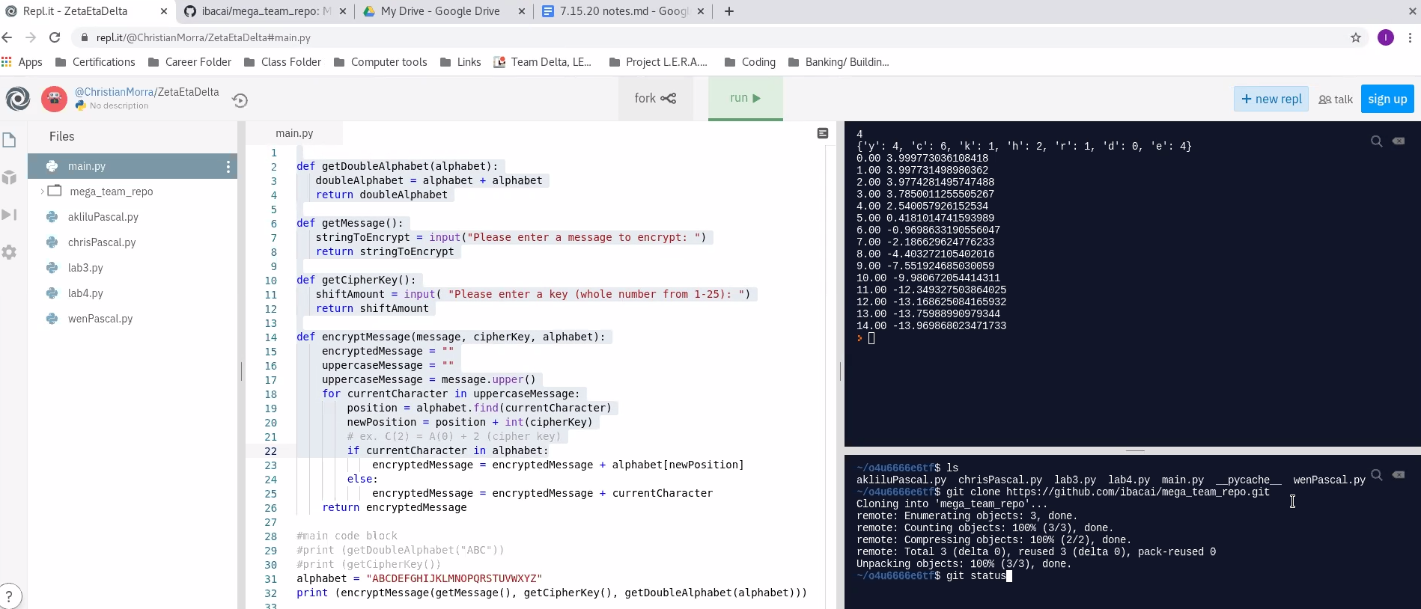

Move multiples files:

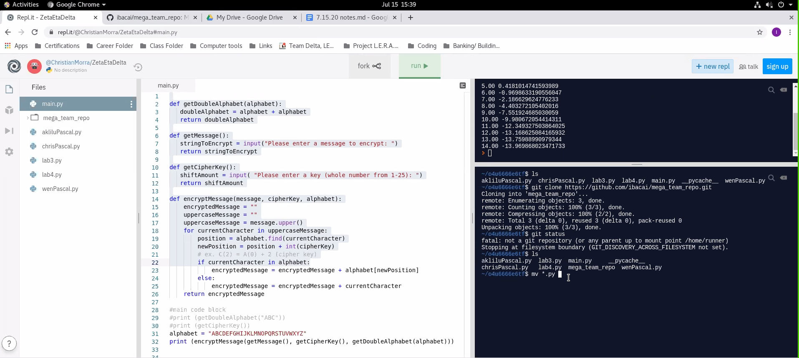

Crashed:

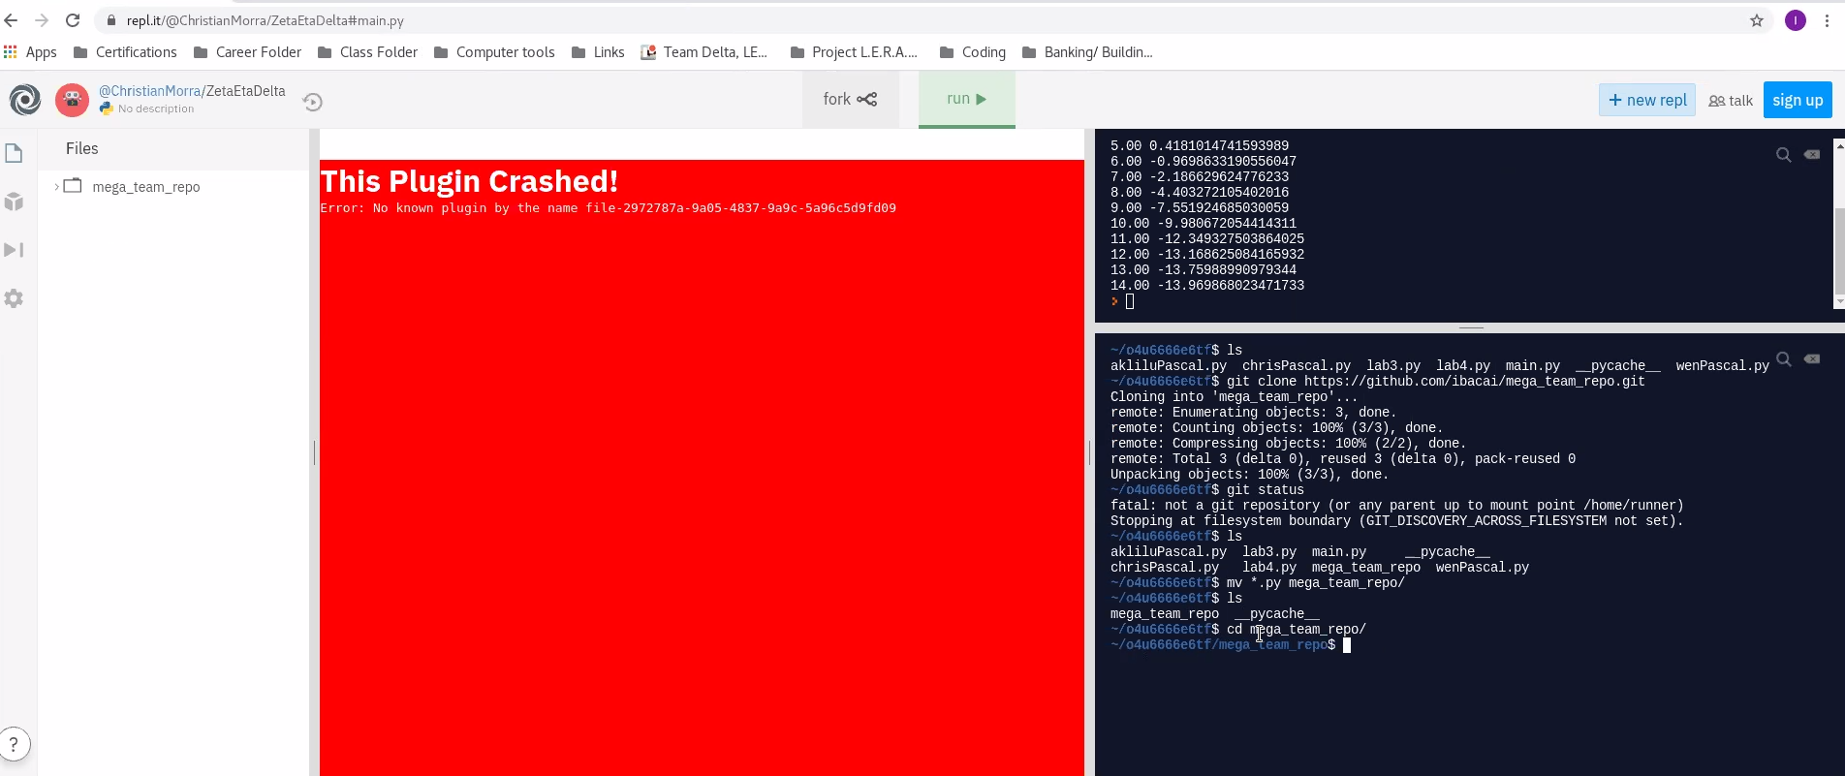

**Worked:**

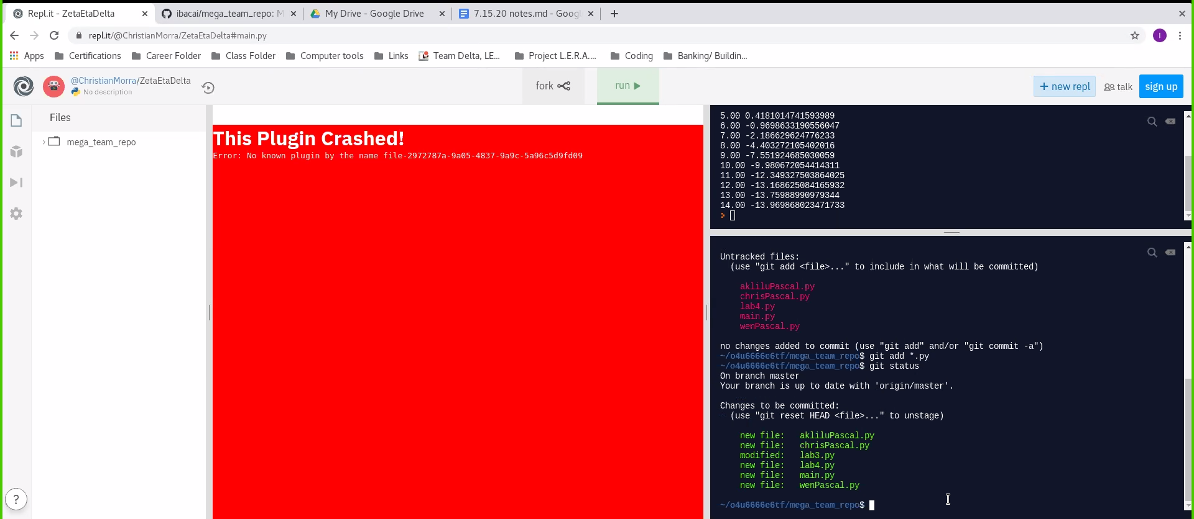

* Create Github:

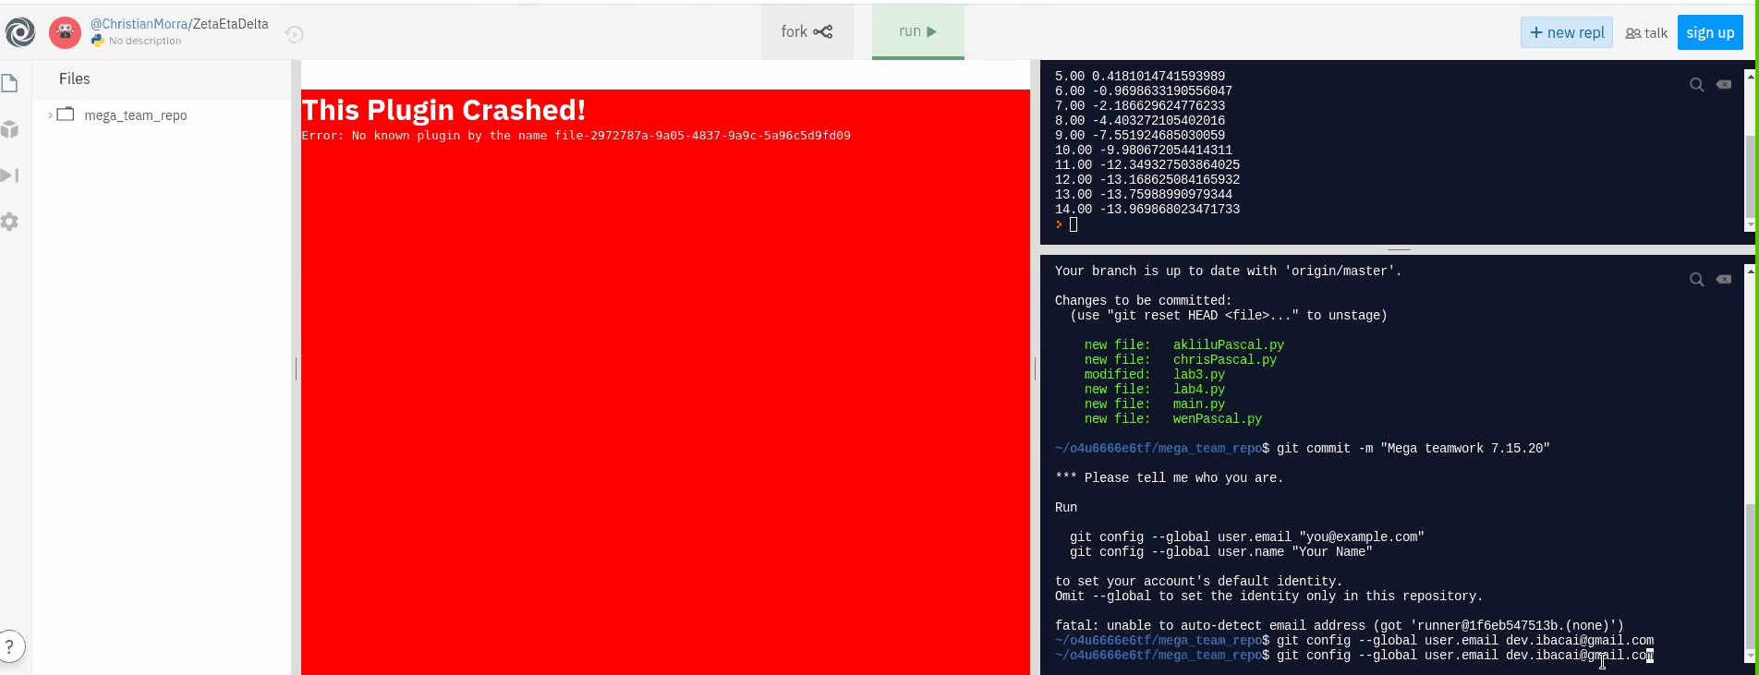

* Git push -f origin master

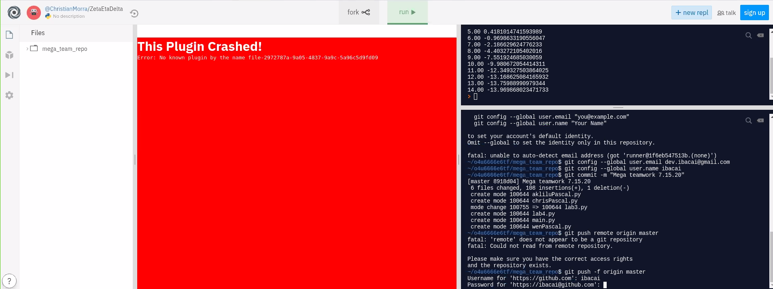

* The push was successful:

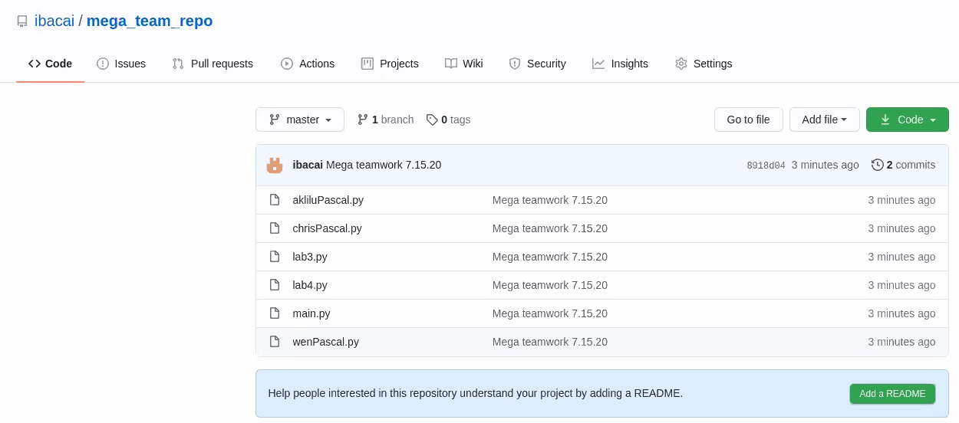

* Change Github to add collaborators :

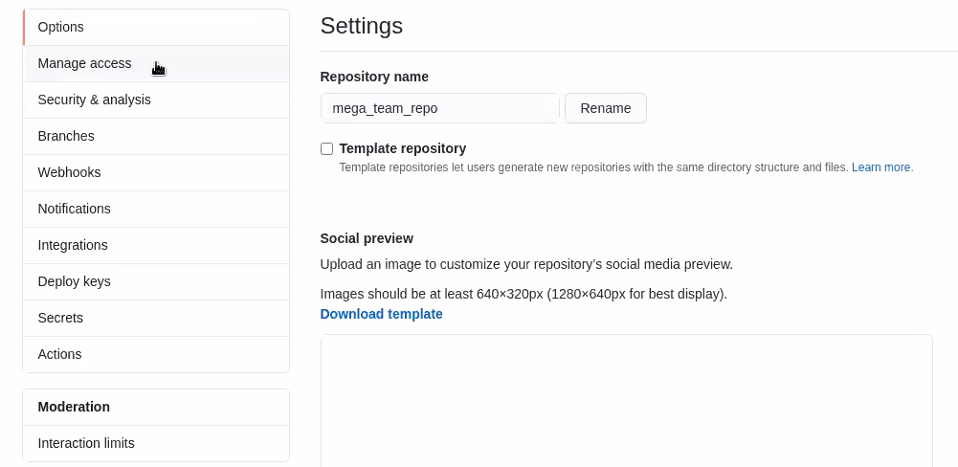

Team Github usernames:

* dev.jessamy
* devambatchew
* dev-arnold-101100
* dev.balde17
* dev.deyessa
* dev.acuna
* devmckenzie
* dev.aufiero
* dev.youta
* devbalde17
* dmalcolm1
* hanybee73
* Team Zeta Github: <https://github.com/devmorra/zetaTest>

**Elias posted challenge:** [**https://github.com/bashadmin/lab_e/blob/master/PYLAB1.MD**](https://github.com/bashadmin/lab_e/blob/master/PYLAB1.MD)

**Team Overview:**

**Team Delta:**

Project Manager - Ivan

Analyst - Michael

Quality Assurance - Melvin

Software Developer - Jarred

Database Administrator - Lord

**Team Zeta:**

Project Manager - Yonatan

Analyst - Darrius

Quality Assurance - Veronica

Software Developer - Christian

Database Administrator - Desmond/Thierno

**Team Eta:**

Project Manager - Edvige

Analyst - Robert

Quality Assurance - Beruk

Software Developer - Horace

Database Administrator - Hana